Voice of the Child/Young Person Form
(Please complete this form directly with the child)

My name is ………………………………………………………………..

I am ……………… Years old

The setting I go to is ……………………………………………………

………………………………….. Helped me to complete this form on ……./.……/…………

My favourite TV programme is ………………………………………..

My favourite film is ………………………………………………

My favourite singer/band is…………………………………………..

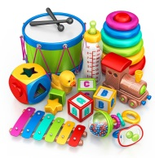
My favourite toy is ……………………………………….

My favourite game to play is …………………………………

My favourite computer game is……………………………………….

My favourite indoor activity is …………………………………….

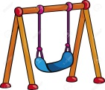
My favourite outdoor activity is …………………………………….

My favourite food is ………………………………………..

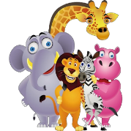
My favourite animal is …………………………………………….

My favourite day out is ……………………………………………

My favourite colour is …………………………………………….

My favourite thing to do at nursery is …………………………………….

My favourite people to spend time with are ………………………………………..

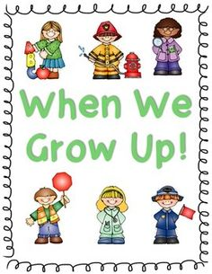
When I grow up I want to be ………………………………………………..

