Food Allergen Risk Assessment for Caterers

People with food allergies must take great care when eating out to avoid certain foods that could cause them harm. As a business you have a legal obligation to ensure that any food you produce or prepare is safe. It is a legal requirement to provide information to consumers about allergenic foods in your dishes when asked. From 1st October 2021 there are also new rules for labelling foods if you package foods onsite before they are ordered or selected by the customer.

Main Food Allergens

There are 14 controlled allergens listed in the legislation which are shown below:

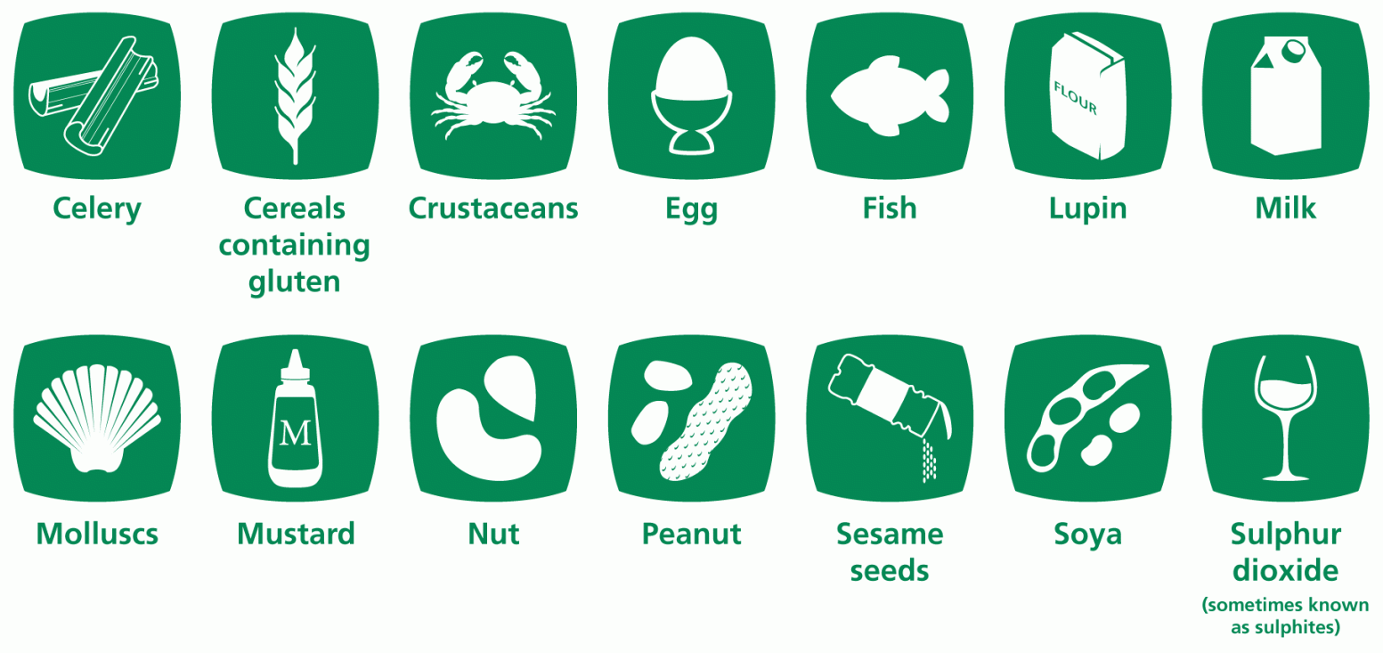
You cannot say that you do not know what allergens are in the food you serve. You are also not allowed to say that all the foods you serve could contain an allergen. You will need to know what is in the food you provide.

Although there are specific allergens listed in the legislation, consumers may ask about other ingredients in your dishes to which they are allergic to, and where you provide information about such ingredients, it must also be accurate and not mislead the customer.

This assessment has been divided into five sections:
- Overall Management & Training,
- Front of House Procedures
- Kitchen Procedures,
- Telephone & Internet Orders (including Buffets/Event catering).
- Pre-packed foods onsite for direct sale

This assessment provides advice and points to consider as part of your allergen management procedures, to assist you when assessing whether the controls you currently have in place are effective and if any improvements can be made when dealing with customers who have food allergies or intolerances.

It includes both legal requirements and advice on good practice which you may wish to include into your allergen management procedures. By following the advice noted within this document you must not assume that your business is fully compliant with the applicable legislation.

There are different ways by which you can demonstrate compliance with the law, if you have devised your own method then this should be discussed with the Inspecting Officer. As a food business operator, it is your responsibility to ensure that you comply with relevant legislation applicable to food allergens and the service of food that is safe to consumers.

Allergen Management and Training
Question | Points to consider
Do you have a system in place for managing  allergens in the food you serve?  Yes No  Do you have allergen emergency procedures in place which staff are aware of?  Yes No  You may wish to use the Emergency Action template in Appendix 1 to assist you should an emergency arise in your food business | You should consider:  - How you identify allergen risks  - Decide who has overall management responsibility for allergens (e.g. Manager/Chef)  - Ensure there is a trained staff member on site at all times  - Ensure that all staff are provided with suitable information, instruction, training and supervision  - Decide on how you intend to communicate allergen information to customers  - If someone is suspected of suffering from a reaction, immediate action must be taken - it is important that staff are aware of this action
Do you provide staff with allergen awareness  training?  Yes No  Have you trained staff specifically on your procedure for dealing with customers who have allergies or intolerances?  Yes No  Can you provide evidence of staff training?  Yes No  Have your staff demonstrated to you that they  understand and can follow your procedure?  Yes No | Free online training is available on the Food Standards Agency website  Other training providers also provide allergen awareness training, which there may be a charge for. Training should consider the following:  - Staff must be informed of the effect of providing the wrong information or serving food containing an ingredient that a customer is allergic to  - Staff must be aware of your procedure to follow if a customer advises they have a food allergy or intolerance  - Staff must have access to and know where to find information on the allergens present in your dishes (Allergen Matrix - see later in this guidance)  - You should consider documenting the training staff have received specifically on food allergies (see example record sheet in Appendix 2 to this note)  You should test staff knowledge on the procedure to be followed and undertake refresher training regularly
Do you have a clear way of providing allergen  information or advising customers where they can obtain information on the allergens in the dishes you serve?  Yes No  How do you provide allergen information to customers or advise them where the information can be found? Detail here: | Information can be provided on your menu, on chalk boards, tickets etc. Alternatively, you can display a sign advising  customers to ask for allergen information – this is known as  "signposting". You may choose to use wording such as:  "Food allergies and intolerances. If you have a food allergy or intolerance, please speak to a member of staff when placing your order for further information"  Where you choose to "signpost" customers to allergen information, this should be provided at the point where the customer makes their order i.e., at the till point, on a menu or other place which is easily noticed by a customer.
The allergen information provided must be accurate and verifiable.  Do you use an allergen matrix to record allergens in your dishes?  Yes No | You must assess the ingredients in your dishes using product labels or information provided to you by your supplier and determine the allergens present in each of your food dishes.  You must also consider any garnishes used or sauces, stocks and cooking oils etc.  You may wish to prepare an Allergen Matrix. This simple matrix can be used to record the allergens present in your dishes.  You can find a blank allergy matrix on the Wigan Council website
Example food labels  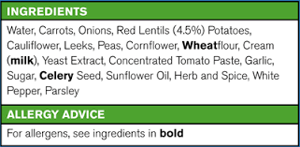  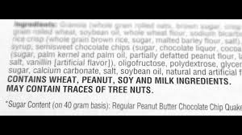 | Your allergen matrix must be regularly reviewed and kept up to date taking into account any changes which may affect the allergen information e.g.  - Change of supplier  - Product substitution (different brands of the same product may have different allergens)  Some manufacturers include statements on their packaging that a product "May Contain" certain allergens. This is only included where there is a real risk the product may contain that allergen following a risk assessment.  Where ‘May Contain’ statements are used, these must be reflected in your allergen matrix under the relevant allergen.  There are many different types of statements used by manufacturer’s, so it is important that this information is available to the customer, e.g.  - May contain…  - May contain traces of…  - Packed in an environment where ‘X’ may be present…  - Produced in a factory which handles…  If you purchase food direct from suppliers and no labels are provided, then you must speak to that supplier and obtain information about the allergens present in the ingredients they supply to you.

Front of house procedures
Question | Points to consider
How do you inform customers about the allergens in the dishes you serve?  Separate allergen menu  Signposting  (see section 1: Allergen management and training for more information)  Other  Please specify: | You should consider the following:  - Where signposting is used, the sign must be prominent and situated at the point where customers make their choices - e.g., at the bar, waiting staff, menus, specials boards etc  - Are all staff aware of where to find the allergen matrix? You could have a dedicated location for your allergen matrix which all staff are aware of  - Staff should not be required to memorise allergen information but should refer to accurate written information. (See Section 1)
Do you have a procedure to be followed when  taking orders from customers with an allergy or intolerance?  Yes No  You must ensure that your procedure considers how a customer's allergies are recorded and communicated to kitchen staff. | You should consider the following:  - Ensure staff have been trained on the procedure to be followed when dealing with allergenic customers  - Ensure that a Manager is available on each shift to manage/oversee customer requests  - Consider how you record a customer's allergies - written on an order ticket or typed on to electronic devices  - How are cross contamination risks during dish preparation communicated to the customer?  - Ensure the correct food/dish is provided to the allergenic customer  - You should regularly supervise staff to ensure that they are following your procedure when dealing with allergen requests.

Kitchen procedures
Storage  Have you considered the risks of cross-contamination of ingredients with all allergenic ingredients when foods are in storage?  Yes No  If you transfer/decant ingredients from their original packaging into your own containers, do you have a way of identifying the allergens present in the product?  Yes No  Specify how you identify the allergens in products if you remove the packaging? | You should consider the following:  - How cross contamination of ingredients can occur e.g., spillages  - Placing opened ingredient packaging into a sealed container where appropriate  - A spillage policy to deal with spillages of one product onto another product  - Ensure that all staff are provided with suitable training and they are effectively supervised
Preparation  Do you follow a procedure when preparing dishes for a customer with an allergy or intolerance?  Yes No  Do you use separate, designated and clean equipment for preparing dishes for a customer with an allergy or intolerance?  Yes No  Do staff ensure they follow strict personal hygiene rules before preparing or handling a dish for a customer with a allergy or intolerance?  Yes No | You should consider the following:  - Consider dish preparation - use of separate equipment and utensils, storage of ingredients, cooking/reheating process (e.g., reuse of oils) and separate preparation area  - Thorough cleaning before you prepare the dish -there must be no visible food debris/crumbs or food residue on surfaces/utensils/equipment etc  - Strict personal hygiene practices - hand washing, using a fresh clean apron  - Any garnishes/toppings/sauces & dressings put on the dish prior to serving  - Ensure that all staff are provided with suitable training and they are effectively supervised  - You may wish to designate preparation of a dish for a customer with an allergy to one member of the kitchen staff so they can take the necessary care in preparation  Note: allergens are always present in the food. Unlike bacteria, cooking will not "kill" or eliminate the allergen, and in some cases, it will make it more powerful.
Describe your kitchen procedure to be followed when preparing a dish for a customer with an allergy or intolerance:

Do you consider cross contamination risks when preparing a dish for a customer with an allergy or intolerance?  Yes No  Do you communicate cross contamination risks to customers with an allergy or intolerance?  Yes No  If you are unsure that you can safely prepare a dish without preventing cross contamination, then you must advise the customer of such and politely advise them that you cannot serve them.  **NEVER GUESS**  Failure to adequately control cross contamination risks may lead to your Food Hygiene Rating being marked down. | If a staff member advises of an order for a customer with an allergy or intolerance, kitchen staff need to assess if they can safely prepare that dish taking into account cross contamination risks.  You should consider the following:  - Size and layout of your kitchen and the potential for cross contamination when staff work close to one another  - Staff practices of effectively washing hands and double dipping into several ingredients using the same utensils  - Where you have fryers where other foods are cooked in which may have contaminated the oil  - Cross contamination from hotplates/panini grills etc  It is good practice to have dedicated equipment for preparing a dish for a customer with an allergy or intolerance - this should be kept in a separate location in the kitchen and thoroughly washed between uses.
Briefly describe how you communicate cross contamination risk to customers?

Phone and internet orders including home delivery
Question | Points to consider
Do you use a website e.g.. Just Eat/Deliveroo to advertise and take orders (either for collection in person or home delivery)?  Yes No  The law requires that you provide allergen information before the order is placed AND at the point of delivery to the customer | You should consider the following:  - Do you have a statement on your website (or third-party website) to advise customers where they can obtain allergen information before they place their order?  - Are all staff aware of how to take orders over the phone or via you own website/other websites e.g. Just Eat/Deliveroo?  - Do staff have access to an up-to-date allergen matrix?  - Do you have printed flyers/menus? If yes, do you have a statement on these to advise a customer how they may obtain allergen information on your dishes?  - Allergen information will need to be very clear, because you will not always know allergen sensitivities for those who will receive the food  Where you use online ordering sites such as Just Eat/Deliveroo to take orders on your behalf, then you must work with them to decide how you will provide allergen information to a person who is considering placing an order with you.
Delivery  Do you have a system in place to identify a meal  which has been prepared for a customer with an  allergy or intolerance at the point of delivery?  Yes No  Briefly describe how you do this below:  Have you considered any cross-contamination risks during transport from your business to the customer?  Yes No | You should consider the following:  - At the point the food is handed over to the customer, they must be able to identify which meal has been prepared specific to their allergy  - Whatever method you use, it must be possible to clearly identify what allergen information relates to what food product and must not confuse the customer. Examples include:  - Stickers applied to each container when filled in your kitchen noting the relevant allergen  - Handwritten note - must be readable and not fade (e.g. use permanent marker) This can either be applied to the containers or written on an outer bag  You must consider any risks of cross contamination which may take place during transport from your food business to the customer's home.  You may wish to double bag foods which have been prepared for a customer with an allergy or intolerance. Equally, you will need to explain to the delivery driver any special transport requirements you want them to follow.
I provide allergen information to the customer at the point of delivery by:

Buffets, Platters and Event catering  Do you clearly label food displays (e.g., buffets) with the allergen content of each dish?  Yes No  Are instructions given to the person who sets out the food?  Yes No  What are they: | You should consider the following:  - Labels/signs must be clear and with the food at all times whilst customers serve themselves  - Think about how you group food items - can you reduce cross contamination by having similar dishes together?  - Do you have cross contamination controls in place?  You may think about:  - Separate serving utensils  - Supervision of customers who may use the same spoon/tongs for various food items and place them down in a different location to where they picked them up  - The layout of buffet foods e.g., try to have dressings/garnishes in a separate location to the main buffet area
Event Catering  Do you have a system in place to record any allergies you are notified of for event catering?  Yes No | You should consider the following:  - You must have a system in place to record any information you are provided about any individual in a group who suffers from an allergy  - You may wish to include a section in your booking form to record any allergies which an individual may suffer from (this can either be completed by you or by the event organiser  - It would be considered good practice to prepare a separate plate sized platter for anyone attending an event who suffers from allergies (this should be labelled appropriately)
- Prepacked foods onsite for direct sale (PPDS)
Question | Points to consider
Do you pack foods onsite?  Yes No  Would the food already be in the packaging at the time it was ordered or selected by the customer?  Yes No  PPDS is food which is packaged at the same place it is offered or sold to consumers and is in this packaging before it is ordered or selected.  If you do handle pre-packed food for direct sale onsite are you ready for the changes/have you implemented the changes for the correct labelling on the food? (applicable from 1/10/21)  Yes No | From 1st October 2021, if you pack foods onsite and it is packaged before it is ordered or purchased by the customer, you must have certain information on the label including:  - The name of the food  - An ingredients list with the allergens emphasised (in bold or CAPITALS)  - A ‘may contain’ statement if there is a chance that the product may have an unintended allergen (this is based on the outcome of your risk assessment)  Visit the Food Standards Agency website for more information

Appendix 1: Emergency action template

Allergic Reaction
Emergency Action

If an allergic customer becomes ill they may be suffering from an allergic reaction which may include ANAPHYLAXIS. This is a very serious reaction which requires prompt action.

Signs to look out for of an allergic reaction including anaphylaxis

- Tingling or itching in the mouth
- A raised, itchy red rash (hives)- in some cases the skin can turn red and itchy, but without a raised rash
- Swelling of the face, mouth, throat or other areas of the body
- Difficulty swallowing
- Wheezing or shortness of breath
- Feeling dizzy and lightheaded
- Feeling sick (nausea) or vomiting
- Abdominal pain or diarrhoea
- Hayfever like symptoms such as sneezing, itchy eyes
- Clammy skin
- A fast heartbeat
- Collapsing or losing consciousness

TAKE IMMEDIATE ACTION
- Call 999 or 112 (IRE) straight away and tell ambulance control that you suspect a severe allergic reaction. Give them accurate location details
- Alert your member(s) of staff who have been given first aid training
- If someone is having a severe allergic reaction, then they may have medication, like an auto-injector or ‘epi-pen’. This is a pre-filled injection device containing adrenaline which when injected, can help reduce the body’s allergic reaction.
  - Check if they have one, and if they do, help them to use it or do it yourself following the instructions.
- Help them to get comfortable and monitor their breathing and level of response.
  - Repeated doses of adrenaline can be given at five-minute intervals if there is no improvement or the symptoms return.
- Ask other customers if there is a doctor on the premises
- Ensure a member of staff stands at the entrance to direct the ambulance crew to the patient

Prompt and immediate action can save lives.

Appendix 2 Staff Training Record

Staff Name | Position | Training received | Date

